Wellbeing at Ardrossan Academy
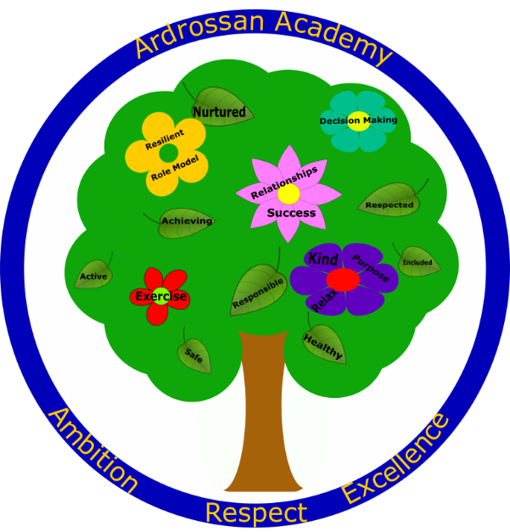
What is wellbeing?
Wellbeing can be understood as how people feel and how they function, both on a personal and a social level, and how they evaluate their lives as a whole.
(Mental Health Foundation)
Wellbeing is fundamental to our health and overall happiness. Having a strong and well-adapted sense of wellbeing can help us overcome difficulties and help us achieve our goals in life. In short, having high levels of wellbeing helps us to be the best versions of ourselves.
Good mental wellbeing means that, in general, you feel comfortable and confident; you're able to express your thoughts and feelings, nurture good relationships with other people, and be resilient. This means you can bounce back quickly when things go wrong, adapt to change and cope with the stresses of everyday life.

Key facts about wellbeing
2. The eight wellbeing indicators connect and overlap.
For example, a health difficulty may have an effect on a child or young person achieving their goals or being active. When considered together the different elements of wellbeing give the whole picture of a child's or young person's life at a particular point in time.
1. Every child or young person should be safe, healthy, achieving, nurtured, active, respected, responsible and included.
These eight indicators help make sure everyone - children, parents, and the people who work with them, such as teachers and health visitors - has a common understanding of wellbeing.
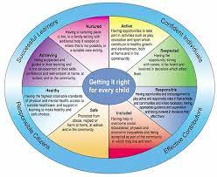
3. A child's or young person's wellbeing is influenced by everything around them.
This includes their individual circumstances, the support they get from their family and community, and the services that support them. Factors such as adequate sleep, play and a healthy, balanced diet have a positive impact on all aspects of a child's or young person's wellbeing. While the effects of poverty and isolation can have a negative effect on their wellbeing.

4. It is up to all of us - parents, early learning providers, health visitors, teachers, GPs, police - to work together to promote, support and safeguard the wellbeing of all of our children and young people.
Children and young people have different experiences and needs at different times in their lives. Understanding how this affects their wellbeing, and providing the right support when they need it, helps them grow and develop and reach their full potential.

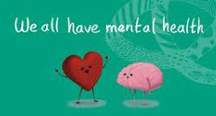
Mental Health
Mental health includes our emotional and social wellbeing. It affects how we think, feel, and act towards ourselves and others. It also helps determine how we handle stress, relate to others, and make choices (positive or negative). Mental health is important at every stage of life, from childhood to adulthood. Everyone has mental health. Sometimes mental health can be seen as negative and people don’t like to speak about it.
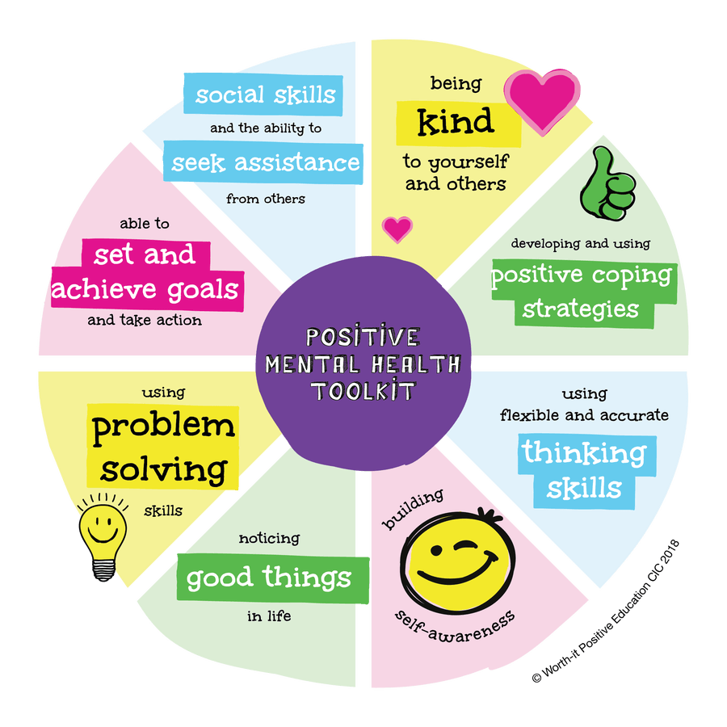
When you think of mental health, sometimes you just think of illnesses like: depression, mood disorders, suicidal thoughts, eating disorders and anxiety. If you have any of these feeling then you should talk to someone you trust and seek help. Talking to someone is the first step to feeling better.

Positive Mental Health can be:
- Feeling good about yourself
- Not letting your emotions overwhelm you and learning methods to cope with all the emotions you feel
- Making and building positive relationships with others
- Feeling comfortable and confident to speak to others
- Feeling safe at home and in the community

Ways to look after your Wellbeing
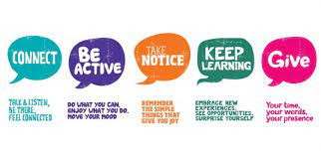
- Get approximately 8 hours of sleep per night
- Exercise regularly
- Have a balanced diet
- Be social, hang out with friends
- Try to do something you like everyday
- Eat healthy and treat yourself - 5 a day & 8 glasses of water
- Join a club – sports, choir, walking, gardening, drama
- Relax and take time for yourself – read, take a bath, listen to music, take a walk in nature, do yoga

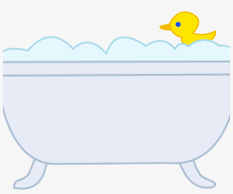

Self-care strategies

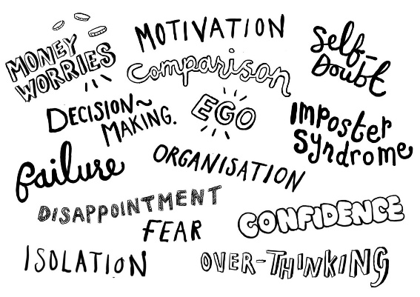
How to take you mind off things: Listen to music, go for a walk, take a nap, and talk to someone you trust or bake something

How to keep active: go for a walk, do some yoga, dance, kick a ball around, take the dog out, go to an after school club or go to the gym with a friend.

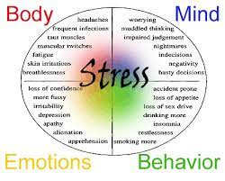
Stress coping mechanisms: take some time away from your phone and talk to someone that would understand or help when you are feeling stress. Watch your favourite TV show or movie. Read a book or do some colouring.

Extra tips: drink enough water, eat healthy foods and do something you love every day.

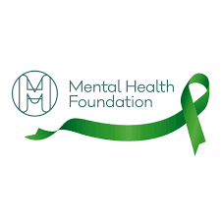
Where to get help

In School
- Talk to a friend or an adult you trust
- Speak to your Pastoral Support Teacher
- Arrange an appointment to speak to our school counsellor Yann
- Arrange an appointment to speak to our school nurse

Websites
- Breathing Space (16+) Contact free on: 0800 83 85 87 (Mon-Thurs 6pm-2am, Fri 6pm-Mon 6am) Visit Website: https://breathingspace.scot (webchat available)

- Child line Contact free on: 0800 1111 Visit Website: https://childline.org.uk (webchat available)
- Samaritans Contact free on: 116 123 Visit Website: http://www.samaritans.org

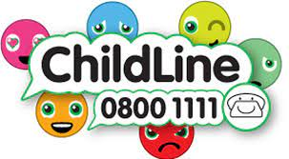
- Give Us A Shout Text 85258 for 24/7 Free Support & Advice Visit Website: https://www.GiveUsaShout.org/

Apps
- Calm: Best for visualizing and looking inward
- Headspace: Best for learning lifelong mindfulness skills
- Insight Timer: Best for free guided meditations and talks from celebrities and gurus around the world
- Pacifica: Best for breaking the vicious cycle of negative thoughts
- TalkSpace: Someone to talk to

